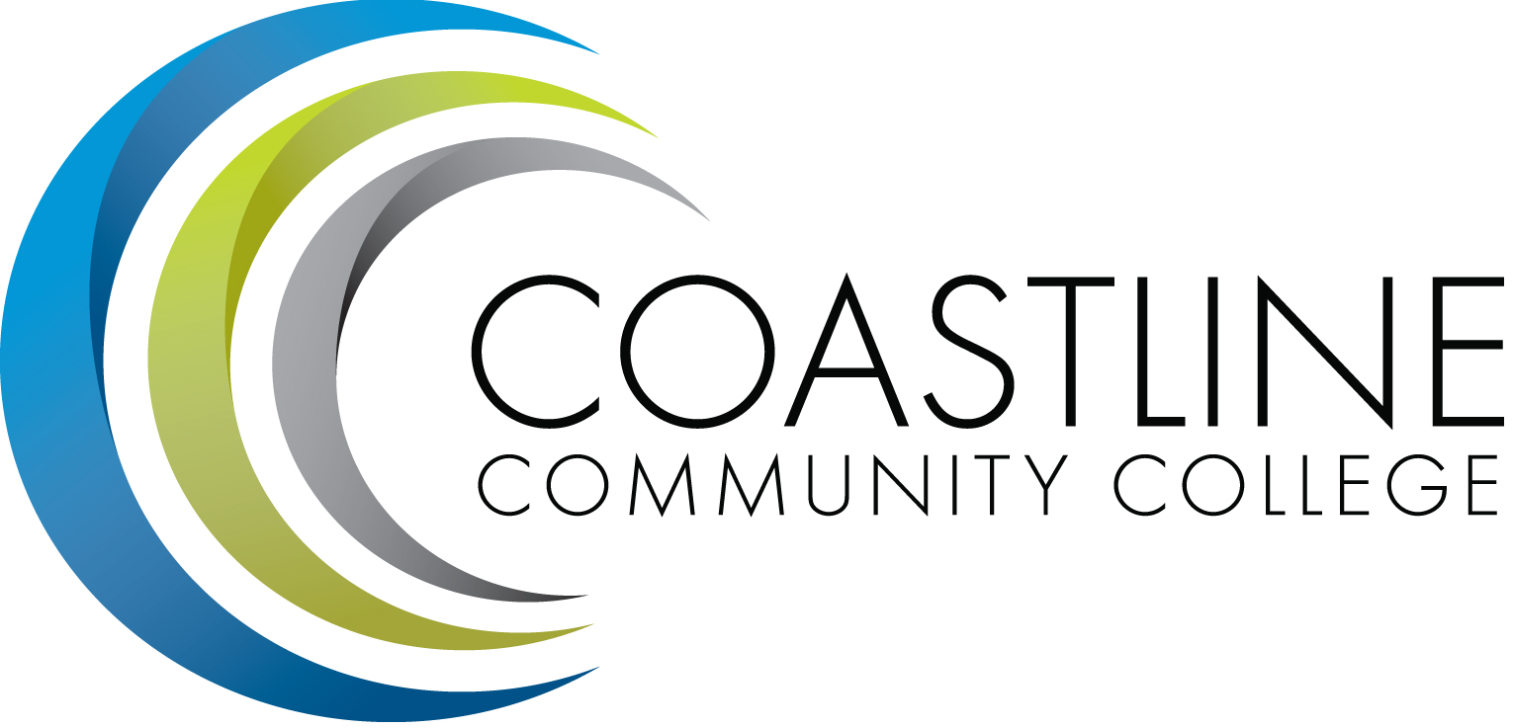
Planning, Institutional Effectiveness, and Accreditation Committee (PIEAC)
October 21, 2015
1:30 p.m. to 3:30 p.m.
Fourth Floor Conference Room

- CALL TO ORDER
  - Roll Call
  - Welcome
  - Adoption of Agenda
  - Approval of Minutes: September 28, 2015

- DISCUSSION ITEMS
2.1 College Mission Statement A. Holliday
2.2 Committee Survey V. Rodriguez
2.3 Refining the areas of focus A. Zentner
2.4 Established EMP SWOT Analysis Work Group A. Zentner
2.5 KPI Scorecard A. Zentner

- STANDING REPORTS
3.1 Accreditation V. Rodriguez
3.2 Budget Committee R. Lockwood
3.3 Program Review A. Zentner
3.4 Grants D. Aistrich
3.5 President’s Report L. Adrian
3.6 Wing Reports V. Rodriguez, C. Nguyen, R. Miyashiro
3.7 College Council V. Rodriguez
3.8 Facilities C. Nguyen
3.9 Contract Education J. Groot
3.10 Other Committees Committee

- ANNOUNCEMENTS (1-2 minutes per)

- ADJOURNMENT

